Week 4 Lab Task – Complete Vulnerability Assessment Report
NIAI NAVTTC — Certified Ethical Hacker (CEH)
Student: Muhammad Nadeem
Date: 19 April 2026
Target: Metasploitable 2 (IP: 192.168.93.130)
Attacker:Kali Linux

1. Introduction
This report documents a comprehensive vulnerability assessment performed in an isolated virtual lab environment only.
Tools used:
- `nmap --script=vuln` (Nmap Vulnerability Scripting Engine)
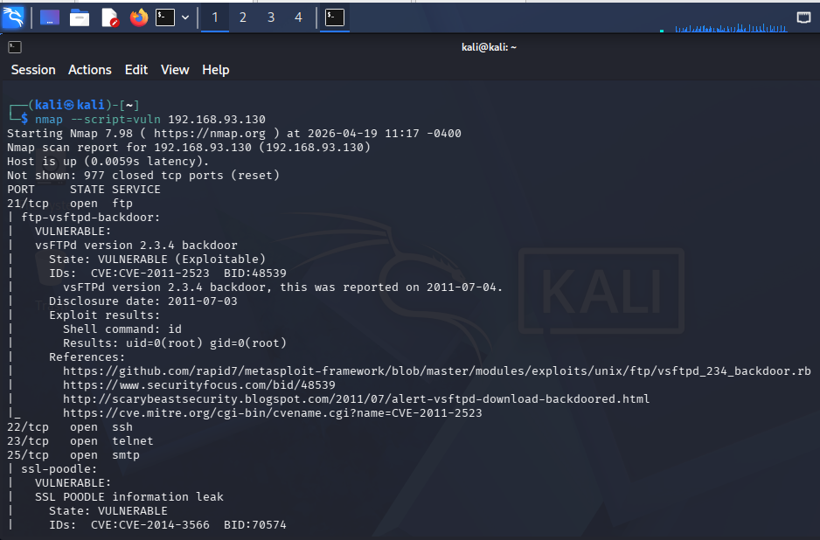

- `nikto -h http://192.168.93.130` (Web Server Scanner)
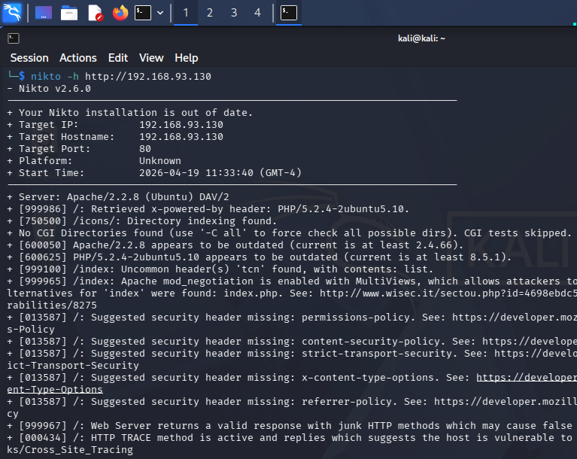

Objective: Identify vulnerabilities in network services, servers, and web applications, perform risk analysis, prioritize findings, and provide remediation steps.

2. Scan Summary
- Nmap Vuln Script identified multiple critical backdoors , weak TLS configurations, SQL injection points, and remote code execution vectors.
- Nikto confirmed outdated software, directory indexing, exposed sensitive files (`phpinfo.php`), and missing security headers.
- The target is extremely vulnerable (classic Metasploitable 2 lab image). Multiple services allow remote root access without authentication.
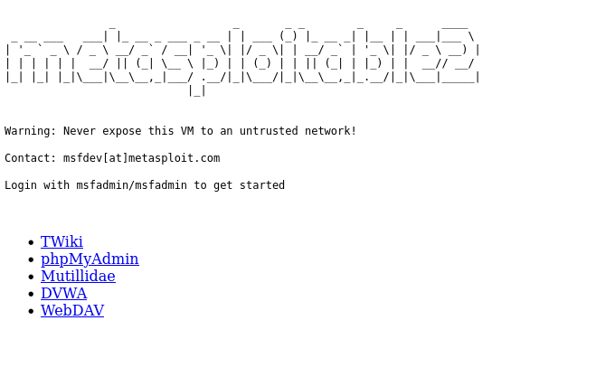

3. Prioritized Risk Table

| Vulnerability | Severity | CVSS | How Found | What it Allows Attacker to Do | Recommended Fix |
|--------------------------------------------|----------|------|----------------------------|--------------------------------------------------------|----------------------------------------------|
| vsFTPd 2.3.4 Backdoor (Port 21) | Critical | 9.8 | Nmap --script=vuln | Remote root shell (uid=0) without credentials | Remove or upgrade vsftpd immediately |
| UnrealIRCd Backdoor (Port 6667) | Critical | 10.0 | Nmap --script=vuln | Remote command execution as root | Remove or update UnrealIRCd |
| SQL Injection in Mutillidae (multiple pages) | High | 8.8 | Nmap http-sql-injection | Database dump, admin account takeover, data manipulation | Use prepared statements, input sanitization |
| Outdated Apache 2.2.8 (Ubuntu) | High | 7.5 | Nikto + Nmap | Remote code execution via known CVEs | Upgrade to latest Apache 2.4.x |
| Outdated PHP 5.2.4 | High | 9.3 | Nikto | Multiple RCE, information disclosure | Upgrade to PHP 8.x |
| Telnet Service Enabled (Port 23) | High | 7.2 | Nmap port scan | Plaintext credential theft & remote access | Disable Telnet, enforce SSH only |
| SSL POODLE & Weak Diffie-Hellman (multiple services) | High | 7.5 | Nmap ssl-* scripts | Man-in-the-middle decryption of traffic | Disable SSLv3, use strong DH groups ≥ 2048 |
| Exposed phpinfo.php | High | 7.0 | Nikto | Full system & PHP configuration disclosure | Delete phpinfo.php permanently |
| Slowloris DoS Vulnerability (Port 80) | Medium | 6.5 | Nmap http-slowloris-check | Denial of Service by exhausting web server resources | Implement request timeouts & rate limiting |
| Directory Indexing + Exposed Directories | Medium | 5.5 | Nikto + Nmap http-enum | Information disclosure (source code, configs) | Disable directory listing in Apache |
| Missing Security Headers (CSP, HSTS, etc.) | Medium | 5.0 | Nikto | Increases impact of XSS/CSRF attacks | Add proper security headers |
| RMI Registry Remote Code Execution | High | 8.5 | Nmap rmi-vuln-classloader | Remote code execution via Java RMI | Restrict RMI or remove service |

Prioritization Rule Applied: Critical → High → Medium (as required by the lab task).

4. Key Findings Explained (Top Critical & High Items)

1. ‘‘vsFTPd Backdoor’‘
- Discovered by Nmap exploit script (confirmed root shell with `id` command).
- Attacker gains ‘‘full root access’‘ instantly.
- Fix: `apt remove vsftpd` or patch to a clean version.

2. ‘‘UnrealIRCd Backdoor’‘
- Trojaned version running on port 6667.
- Instant remote root command execution.

3. ‘‘SQL Injection (Mutillidae)’‘
- Nmap detected ‘‘dozens’‘ of injectable URLs (notes.php, login.php, etc.).
- Allows complete database takeover.

4. ‘‘Outdated Apache & PHP’‘
- Apache 2.2.8 and PHP 5.2.4 are from ‘‘2008’‘ — hundreds of public exploits exist.

5. ‘‘Exposed phpinfo.php’‘
- Reveals full server configuration, paths, and modules — perfect reconnaissance for further attacks.

5. Conclusion & Overall Risk Level
‘‘Overall Risk Level: CRITICAL’‘

The target system is ‘‘completely compromised’‘ in its current state. An attacker can gain root access in seconds using the vsFTPd or UnrealIRCd backdoors alone. Web applications (Mutillidae, DVWA) contain classic OWASP Top 10 vulnerabilities (SQLi, CSRF, etc.).

‘‘Immediate Recommended Actions:’‘
1. Fix ‘‘Critical’‘ vulnerabilities first (vsFTPd & UnrealIRCd backdoors).
2. Disable all unnecessary services (Telnet, SMTP, NFS, etc.).
3. Update/patch Apache, PHP, and all web applications.
4. Implement proper security headers and disable directory indexing.

‘‘Lab Environment Note:’‘ All scans were performed ‘‘exclusively’‘ in the isolated VirtualBox lab (Kali → Metasploitable). No real networks were touched.

